Rj45 to industrial M12 Ethernet

The intent for this cable is to provide a way to communicate with M12 connector based equipment using rj45 connectors. This can also serve as instructions for replacing some cables on newer trains.

Parts

1. Field installable industrial Ethernet male RJ45 connector
   1. Female Digikey PN a134473-ND
   2. Digikey PN xxxxxxxxxxxx
   3. Digikey PN xxxxxxxxxxxx
   4. Digikey PN xxxxxxxxxxxx
2. Cable
   1. TE equipment 2 twisted pair shielded Ethernet cable
   2. Other cable
3. M12 D-coded 4 position connector
   1. Male plug = Digikey PN xxxxxxxxxxxx
   2. Female plug = Digikey PN xxxxxxxxxxxx
4. 4 Wire ferrules
   1. Tri-Met part number XXX-XXXXx

Assembly

1. Identify cutback length for M12 connector. ¾ inch
2. Unwind each pair ¾ inch and add ferrules to the 4 wires
3. Insert wires into the screw terminals of the M12 plug and tighten to 92ft-lb
4. Identify cutback for rj45 connector per connector instructions
5. Insert wire and close up the connector
6. Test cable

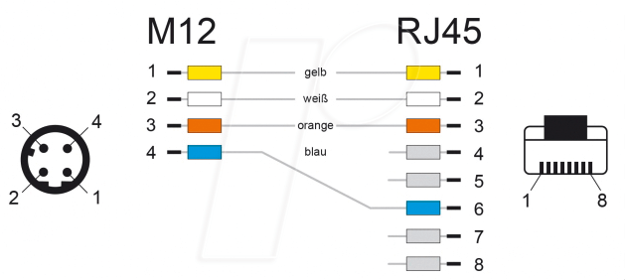Pinout

M12 wire color RJ45

1 yellow 1

2 white 2

3 orange 3

4 blue 6